Mathematical Models in Marketing

Yegor Tkachenko, Sibel Sozuer Zorlu

***Networks, Crowds, and Markets*, Chapter 9: Auctions**

David Easley, John Kleinberg

Summary by Sibel Sozuer Zorlu, Yegor Tkachenko

11/18/2017

*2 auction scenarios.*

* Single seller – many buyers (our focus)
* Single buyer – many sellers (procurement auction)

*Intrinsic assumption*. Each bidder has an intrinsic value for the auctioned item. Auctions are used to discover it. If value were known, there would be no need for the auction.

*Auction types.*

* *Ascending-bid (English) auctions.* Price is raised and bidders drop out, until one final bidder remains, and he pays the price at that moment.
* *Descending bid (Dutch) auctions.* Price is descending until the first bidder agrees and pays it.
* *First-price sealed-bid auctions*.
* *Second-price sealed-bid (Vickery) auctions*.

*Critical feature* – seller’s ability to commit to the mechanism.

*Surprise.*

* Descending-bid auctions are equivalent to first-price sealed-bid auctions.
  + The item goes to a bidder with highest bid *b*.
* Ascending-bid auctions are equivalent to second-price sealed-bid auctions.
  + As prices ascend, bidders drop out. The winner is the last bidder remaining (has highest bid), and he pays the price at which the last bidder drops out (that the last bidder was not willing to go above, second-highest bid).
* In ascending-bid auction you stay until it reaches your true valuation.
  + If you overstay, you either lose and get nothing, or win and pay more than your valuation, losing money.
  + If you drop out early, you get nothing and lose a chance to win an item at a price below your true value.
  + This says that in such auctions people should use their true values as the bids. In other words, these auctions are truth-revealing.

It may seem weird to intentionally undercharge individuals in the second-price auction, but

1. this is offset in the first-price auctions, as people tend to bid lower here than in the second price auction – so that! there will be no difference in the winning bids;
2. truthful bidding in the second-price auction has advantage in that it precludes manipulation tries.

*Second-price auction game*

* If *bi* is not a winning bid, then payoff of *i* is 0, otherwise it is $v_{i}-b_{j}$ for i's valuation *vi* and second-largest bid *bj.*
* *Claim:* In a sealed-bid second-price auction, it is a dominant strategy for each bidder *i* to pick bid $b_{i}=v_{i}$

Proof:

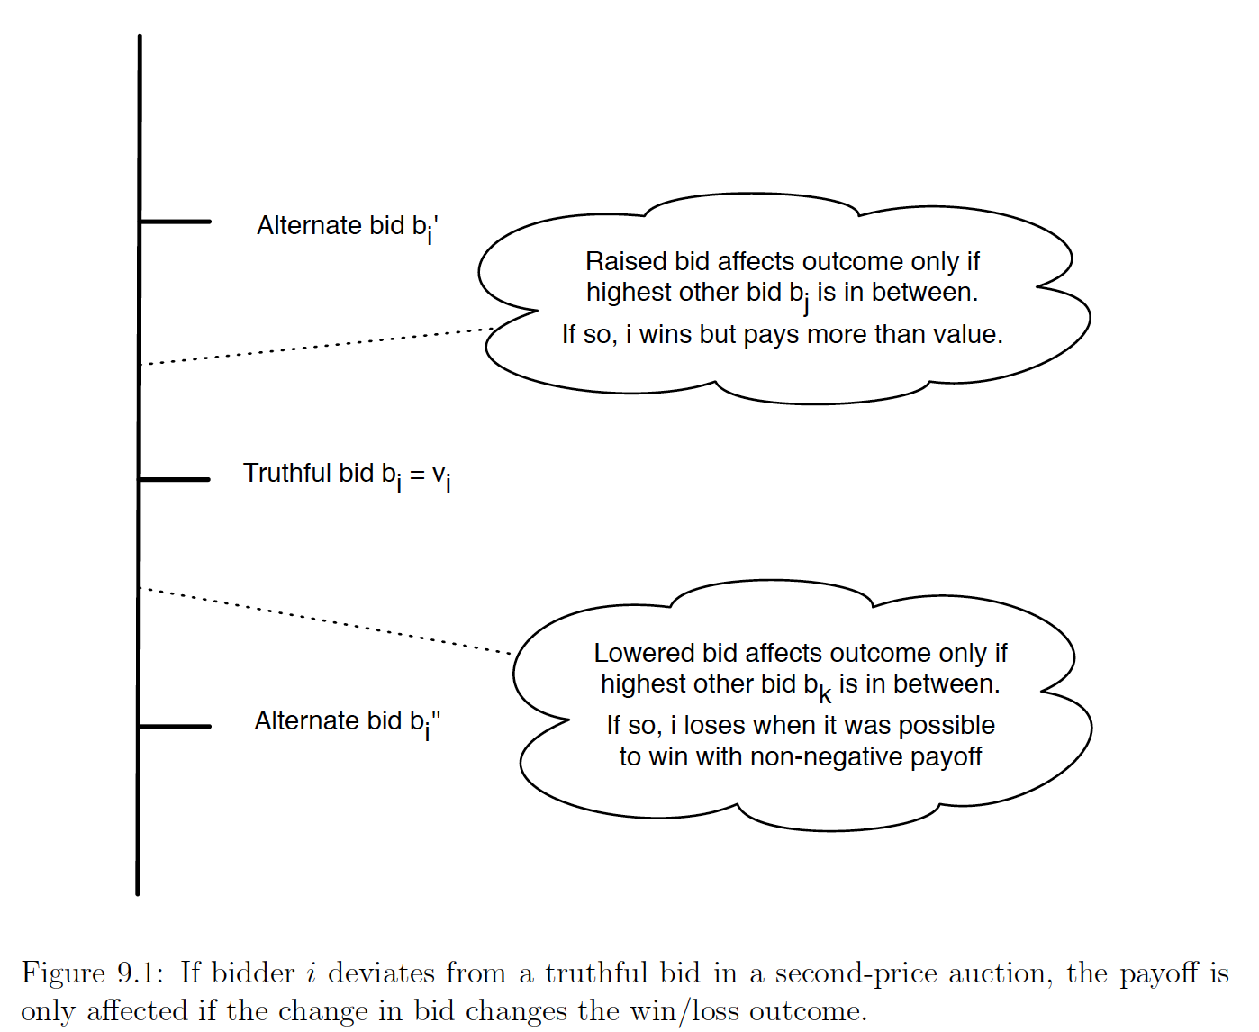

*Key idea:* in the second-price auction your bid determines only whether you win or lose, but not how much you pay in the event that you win!

*First-price auction game.* Situation is complex, as bid determines both if the person wins and amount.

* If *bi* is not a winning bid, then payoff of *i* is 0, otherwise it is $v_{i}-b_{i}$ for i's valuation *vi*.
* Two opposing forces:
  + You bid too close to your true value – payoff won’t be too large.
  + You bid too far below – you lose chance to win.
* To resolve this problem, we need to know sth about other bidders, e.g., distribution of valuations.

*All-pay auction* – similar to first-price auction, but everyone pays their bids, not just the winner. One example, lobbying. Generally, as in fpa, we want to bid lower than true, but not too low.

*Common values and winner curse*. If everyone has the same valuation plus some error, anyone who makes an error upwards and overbids is more likely to be the winner of the auction. This leads to consistent disillusionment with the win.

*Bidding Strategies*

n bidders $v_{i} \sim U\left(0,1\right), i=1,..,n$

bidding strategy s(.) strictly increasing and diff’ble $b=s\left(v\right)≤v and s\left(0\right)=0$

*First-price auction*

Expected payoff for bidder i, $G\left(v_{i}\right)=v_{i}^{n-1}(v_{i}-s\left(v_{i}\right))$

For s(.) to the equilibrium strategy, by Revelation Principle, $v_{i}^{n-1}\left(v_{i}-s\left(v_{i}\right)\right)≥ v^{n-1}\left(v_{i}-s\left(v\right)\right)$ $for all v∈[0,1]$

The optimal strategy is $s\left(v_{i}\right)=\frac{n-1}{n} v_{i}$

As n increases, the bidders have to bid more aggressively.

For a general distribution of valuations, we solve $s'\left(v_{i}\right)=(n-1)\left(\frac{f\left(v_{i}\right){(v}_{i}-s(v_{i} ))}{F(v_{i})}\right)$

*All-pay auction*

Expected payoff for bidder i, $G\left(v_{i}\right)=v_{i}^{n-1}\left(v_{i}-s\left(v_{i}\right)\right)+(1-v_{i}^{n-1})\left(-s\left(v_{i}\right)\right)$

For s(.) to the equilibrium strategy, by Revelation Principle, $v_{i}^{n}-s\left(v_{i}\right)≥ v^{n-1}v_{i}-s\left(v\right)$ $for all v∈[0,1]$

The optimal strategy is $s\left(v_{i}\right)=\frac{n-1}{n} v_{i}^{n}$

As n increases, the bids reduces exponentially.

*Seller Revenue*

Revenue Equivalence: The seller’s revenue is the same across all auctions = (n-1)/(n+1)